The Mixed Nuts

Valentines Set ABC Last Revised on 2016.02.15

ValABC-01-M01-Love Is Just Around The Corner(KV).2014.03.06.pdf
ValABC-02-B13-My Funny ValABC-entine(KVF).2014.03.14.pdf
ValABC-02-B13-My Funny ValABC-entine(KVM).2014.03.14.pdf
ValABC-03-L16-Love Is A Many-Spendored Thing(KVF).pdf
ValABC-03-L16-Love Is A Many-Spendored Thing(KVM).pdf
ValABC-04-D03-Besame Mucho(KVF).2014.02.15.pdf
ValABC-04-D03-Besame Mucho(KVM).2014.02.15.pdf
ValABC-05-K13-Tennessee Waltz(KVF).2015.01.17.pdf
ValABC-05-K13-Tennessee Waltz(KVM).2015.01.17.pdf
ValABC-06-C09-Come Fly With Me(KVF).pdf
ValABC-06-C09-Come Fly With Me(KVM).pdf
ValABC-07-E11-Body And Soul(KVF).pdf
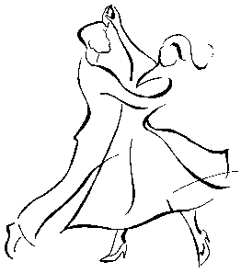
ValABC-07-E11-Body And Soul(KVM).pdf
ValABC-08-N11-That's Amore(KV).2015.01.25.pdf
ValABC-09-AA05-At Last(KVF).2015.02.08.pdf
ValABC-09-AA05-At Last(KVM).2015.02.08.pdf
ValABC-10-C14-I Can't Give You Anything But Love(KV).2014.03.07.pdf
ValABC-11-D16-C'est Si Bon(K).2014.03.12.pdf
ValABC-12-B05-Misty(KVF).2015.02.11.pdf
ValABC-12-B05-Misty(KVM).2015.02.11.pdf
ValABC-13-E13-Till There Was You(KVF).2015.08.13.pdf
ValABC-13-E13-Till There Was You(KVM).2015.08.13.pdf
ValABC-14-J02-Let Me Call You Sweetheart(KVF).2014.02.15.pdf
ValABC-14-J02-Let Me Call You Sweetheart(KVM).2014.02.15.pdf
ValABC-15-F07-It Had To Be You(KVF).2015.02.08.pdf
ValABC-15-F07-It Had To Be You(KVM).2015.02.08.pdf
ValABC-16-X10-Crazy(KV)2015.02.14.pdf
ValABC-17-E03-I've Got You Under My Skin(KVF).2015.02.08.pdf
ValABC-17-E03-I've Got You Under My Skin(KVM).2015.02.08.pdf
ValABC-18-C15-Fly Me To The Moon(KVF).2015.02.08.pdf
ValABC-18-C15-Fly Me To The Moon(KVM).2015.02.08.pdf
ValABC-19-F05-Someday My Prince Will Come(K).2014.02.09.pdf
ValABC-20-A09-Love Me Tender(KVF).2014.10.10.pdf
ValABC-20-A09-Love Me Tender(KVM).2015.02.01.pdf
ValABC-21-M06-Baby Face(KVF).2015.15.17.pdf
ValABC-21-M06-Baby Face(KVM).2015.15.17.pdf
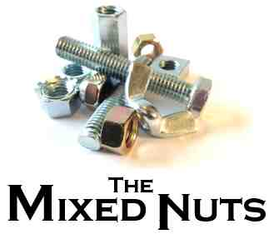
ValABC-22-F01-As Time Goes By(KVF).2015.05.25.pdf
ValABC-22-F01-As Time Goes By(KVM).2015.05.25.pdf
ValABC-23-S08-The Shadow Of Your Smile(KVF).2016.02.15.pdf
ValABC-23-S08-The Shadow Of Your Smile(KVM).2016.02.15.pdf
ValABC-24-AA07-Somebody Loves Me(KFM).2014.05.17.pdf
ValABC-24-AA07-Somebody Loves Me(KVF).2014.05.17.pdf
ValABC-25-B02-Always(KVF).2014.03.14.pdf
ValABC-25-B02-Always(KVM).2014.03.14.pdf
ValABC-26-A17-In The Mood(K).2014.05.17.pdf

